Aaand relax!
Epsom salt is a natural remedy for muscle aches, inflammation, and stress. People sometimes use an Epsom salt bath to relax.
The chemical name for Epsom salt is magnesium sulfate, MgSO₄.
Plan an experiment to prepare pure, dry crystals of magnesium sulfate,
You will need to choose a suitable acid and base for the reaction.
Include a balanced symbol equation in your answer.
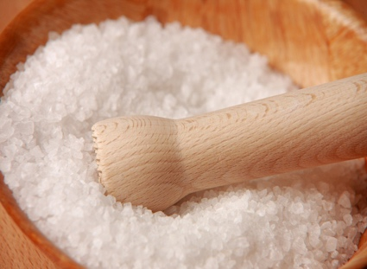

___________________________________________________________________________________________
___________________________________________________________________________________________
___________________________________________________________________________________________
___________________________________________________________________________________________
___________________________________________________________________________________________
___________________________________________________________________________________________
___________________________________________________________________________________________
___________________________________________________________________________________________
___________________________________________________________________________________________
___________________________________________________________________________________________
___________________________________________________________________________________________
___________________________________________________________________________________________
___________________________________________________________________________________________
___________________________________________________________________________________________
___________________________________________________________________________________________
___________________________________________________________________________________________
___________________________________________________________________________________________
___________________________________________________________________________________________

C3.2 - Teacher Guidance
Purpose of this activity
This task presents an opportunity for pupils to
- write an extended response, demonstrating the depth of their understanding of the current topic.
- apply their knowledge in an unfamiliar context.
Pupils should be encouraged to think about the structure of their response. It may be beneficial for pupils to plan their answer in pairs or groups by drawing mind maps or flow charts. Pupils should also be mindful of spelling and grammar in their writing.
Scaffolding this Task
- Break up the answer into some simple steps on the board.
- Underline and define the words in the question which may lead to confusion; base, MgSO₄.
- Supply sentence starters or writing frames to help students structure their response.
- Model part of an answer on the board.
- Give students words that you would like them to include in their answer, such as acid, base, crystal, parts of the symbol equation

Running this Activity
This activity can be run in a number of ways, including;
- Have students plan out the answer together in small groups. They can sketch out a plan for the answer in the form of a mind map or flow chart. They can then go away and write their own response individually or in pairs.
- As an independent formative assessment task or activity
- As a paired activity, where students take turns describing steps in the method
Assessing this question
Credit can be awarded for any of the statements below (or words to this effect).
- A suitable acid = sulfuric acid
- Suitable base = magnesium oxide, magnesium carbonate, magnesium hydroxide (allow magnesium as a base metal)
- Correct balanced symbol equation for the chosen reaction
- Add base to warmed acid until no more dissolves
- Filter off excess base
- Pour solution into an evaporating basin
- Heat gently so majority of water evaporates/ leave for water to evaporate
- Until crystals form
- Pat dry with filter paper/ paper towels
Give credit for an annotated diagram that shows valid points.

